**Computer Organization and Assembly Language**

|  |  |
| --- | --- |
| **Lab 10** | |
| **Topic** | 1. Video memory |

**PART 1**

**VIDEO MEMORY**

***Console Display:***

Note : Each cell represents a word (2 byte).

|  |  |  |  |  |  |
| --- | --- | --- | --- | --- | --- |
| **Row 1,Col 1** | **Row 1,Col 2** | **….** |  |  | **Row 1,Col 80** |
| **Row 2,Col 1** | **Row 2,Col 2** | **…** |  |  | **Row 2,Col 80** |
| **…** | **…** | **…** |  |  | **…** |
| **…** | **…** | **…** |  |  | **…** |
| **…** | **…** | **…** |  |  | **…** |
| **…** | **…** | **…** |  |  | **…** |
| **…** | **….** | **…** |  |  | **…** |
| **…** | **…** | **…** |  |  | **…** |
| **Row 25,Col 1** | **Row 25,Col 2** | **…** | **…** | **…** | **Row 25,Col 80** |

; if you change the second byte, you can change the color of the character.

; character attribute is 8 bit value,

; high 4 bits set background color and low 4 bits set foreground color.

LET AX have 16 bits with character ‘A’ as a value byte and Brown background with white foreground color.

|  |  |  |  |  |  |  |  |  |  |  |  |  |  |  |  |
| --- | --- | --- | --- | --- | --- | --- | --- | --- | --- | --- | --- | --- | --- | --- | --- |
| Blinking of the foreground color | Attribute byte | | | | | | | Value byte | | | | | | | |
| Background | | | Foreground | | | |
| 15 | 14 | 13 | 12 | 11 | 10 | 9 | 8 | 7 | 6 | 5 | 4 | 3 | 2 | 1 | 0 |
| 0 | 1 | 1 | 0 | 1 | 1 | 1 | 1 | 0 | 1 | 0 | 0 | 0 | 0 | 0 | 1 |

; hex bin color

; 0 0000 black

; 1 0001 blue

; 2 0010 green

; 3 0011 cyan possible background colors

; 4 0100 red

; 5 0101 magenta

; 6 0110 brown

; 7 0111 light gray possible foreground color

; 8 1000 dark gray

; 9 1001 light blue

; a 1010 light green

; b 1011 light cyan

; c 1100 light red

; d 1101 light magenta

; e 1110 yellow

; f 1111 white

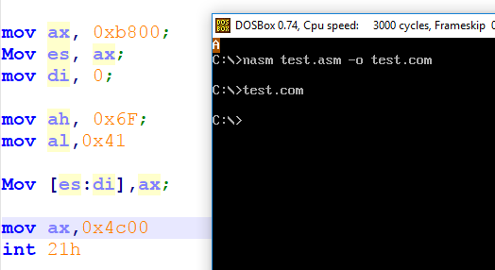

**Display string on screen**

[org 0x100]

jmp start

str1 db 'HELLO WORLD'

start:

mov ax, 0xb800; ;segment address from where video memory starts.

Mov es, ax;

mov di, 0; ;location on screen where we want to display our character.

mov cx, 11; ; string length, 11 characters.

mov si, str1;

mov ah, 0x9A; ; Attribute byte for the characer to be displayed.

l1:

Mov al, [si]; ;reading the characters in al.

Inc si ; pointing to next character in string

Mov [es:di],ax; ; printing message on the screen, whole register of size word is written at

Add di,2; ;physical memory location -> 0xB8001

loop l1

mov ax,0x4c00

int 21h

**Display code which writes and clears the string from screen.**

*USE CTRL+F11 to reduce cycles / sec or CTRL+F12 to increase the speed of dosbox.*

[org 0x100]

jmp start

str1 db 'HELLO WORLD'

start:

mov ax, 0xb800;

Mov es, ax;

mov di, 500;

mov cx, 11; ; string length, 11 characters.

mov si, str1;

mov ah, 0x1A; ; Attribute byte, use any number

l1:

Mov al, [si];

Inc si; pointing to next character in string

Mov [es:di],ax; ; printing message on the screen;

Add di,2;

loop l1

mov cx, 2000; ; total screen locations.

mov ax, 0x0720; Attribute byte (07) and (20h) ASCII for space character.

mov di, 0; ; start from top left

l2:

Mov [es:di],ax; ; writing blank spaces on whole screen

Add di,2;

loop l2

mov ax,0x4c00

int 21h

**For example:**

* Different attribute values of each word
* Different locations can be accessed for the display.

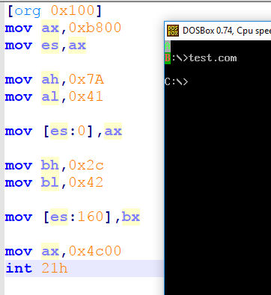

**Display Number Function**

[org 0x100]

jmp start

printnum:

push bp

mov bp, sp

mov ax,[bp+4]

mov cx,0

mov bx, 10

Divide:

; use base 10 for division

mov dx,0

div bx ; remainder goes to DX and quotient goes to AX

push dx

inc cx

cmp ax,0

jnz Divide

Display:

mov ax, 0xb800;

Mov es, ax;

mov di, 0;

l1:

pop ax

add al,0x30

mov ah, 0x07; ; Attribute byte, use any number

Mov [es:di],ax; ; printing message on the screen;

Add di,2;

loop l1

pop bp

ret 2

start:

mov ax, 1234

push ax ; place number on stack

call printnum ; call the printnum subroutine

; mov ax,0x1A34

; Mov [es:di],ax;

mov ax,0x4c00

int 21h